UNITED STATES
SECURITIES AND EXCHANGE COMMISSION
WASHINGTON, DC 20549
_____________________________
FORM 8-K
_____________________________
CURRENT REPORT
PURSUANT TO SECTION 13 OR 15(d) OF THE SECURITIES EXCHANGE ACT OF 1934
Date of Report (Date of earliest event reported): July 29, 2026
_____________________________
MediaAlpha, Inc.
(Exact Name of Registrant as Specified in Its Charter)
_____________________________
Delaware |  |  | 001-39671 |  |  | 85-1854133
(State or other jurisdiction  of incorporation) |  |  | (Commission  File Number) |  |  | (IRS Employer  Identification No.)
700 South Flower Street, Suite 640  Los Angeles, California |  |  | 90017
(Address of Principal Executive Offices) |  |  | (Zip Code)
(213) 316-6256
(Registrant’s telephone number, including area code)
(Not Applicable)
(Former name or former address, if changed since last report)
 |  |  | Check the appropriate box below if the Form 8-K filing is intended to simultaneously satisfy the filing obligation of the registrant under any of the following provisions (see General Instruction A.2. below):
o |  |  | Written communications pursuant to Rule 425 under the Securities Act (17 CFR 230.425)
o |  |  | Soliciting material pursuant to Rule 14a-12 under the Exchange Act (17 CFR 240.14a-12)
o |  |  | Pre-commencement communications pursuant to Rule 14d-2(b) under the Exchange Act (17 CFR 240.14d-2(b))
o |  |  | Pre-commencement communications pursuant to Rule 13e-4(c) under the Exchange Act (17 CFR 240.13e-4(c))
Securities registered pursuant to Section 12(b) of the Act:
Title of each class |  |  |  |  |  | Trading Symbol(s) |  |  |  |  |  | Name of each exchange on which registered
Class A common stock, $0.01 par value |  |  |  |  |  | MAX |  |  |  |  |  | New York Stock Exchange
Indicate by check mark whether the registrant is an emerging growth company as defined in Rule 405 of the Securities Act of 1933 (§230.405 of this chapter) or Rule 12b-2 of the Securities Exchange Act of 1934 (§240.12b-2 of this chapter).
Emerging growth company o
If an emerging growth company, indicate by check mark if the registrant has elected not to use the extended transition period for complying with any new or revised financial accounting standards provided pursuant to Section 13(a) of the Exchange Act. o

Item 2.02 – Results of Operations and Financial Condition.
On July 29, 2026, MediaAlpha, Inc. (“MediaAlpha” or the “Company”) issued a press release announcing its financial results as of and for the second quarter ended June 30, 2026, and its financial outlook for the third quarter and full year of 2026, and posted certain supplemental financial information to the Investor Relations section of its website. Copies of the press release and investor supplement are furnished as Exhibit 99.1 and Exhibit 99.2, respectively, to this Form 8-K and are incorporated by reference herein.
This information shall not be deemed “filed” for purposes of Section 18 of the Securities Exchange Act of 1934, as amended (the “Exchange Act”), or incorporated by reference in any filing under the Securities Act of 1933, as amended, or the Exchange Act, except as shall be expressly set forth by specific reference in such a filing.
MediaAlpha refers to non-GAAP financial information in the press release and investor supplement. A reconciliation of these non-GAAP financial measures to the comparable GAAP financial measures is contained in each document.

ITEM 9.01 – Financial Statements and Exhibits.
(d) Exhibits
Exhibit  No. |  |  | Description
99.1 |  |  | Press release dated July 29, 2026.
99.2 |  |  | Investor Supplement dated July 29, 2026.
104 |  |  | Cover Page Interactive Data File (embedded within the Inline XBRL document).

SIGNATURES
Pursuant to the requirements of the Securities Exchange Act of 1934, the registrant has duly caused this report to be signed on its behalf by the undersigned hereunto duly authorized.
 |  |  | MediaAlpha, Inc.
Date: July 29, 2026 |  |  | By: |  |  | /s/ Jeffrey B. Coyne
 |  |  |  |  |  | Name: |  |  | Jeffrey B. Coyne
 |  |  |  |  |  | Title: |  |  | General Counsel & Secretary

Exhibit 99.1

MEDIAALPHA ANNOUNCES SECOND QUARTER 2026
FINANCIAL RESULTS
Second Quarter Revenue Growth of 26%;
Record Revenue of $316.9 million

Second Quarter Net Income of $41.8 million; Adjusted EBITDA(1)of $29.3 million

Repurchased over $41 million of stock during the First Half of 2026

Los Angeles, CA (July 29, 2026) – MediaAlpha, Inc. (NYSE: MAX) ("MediaAlpha" or the "Company"), today announced its financial results for the second quarter ended June 30, 2026.

“We delivered record second-quarter results as demand continued to broaden across our marketplace,” said Steve Yi, CEO of MediaAlpha. “Quarter after quarter, more of our carrier partners are unlocking advertising spend and leaning further into our marketplace. Looking to the future, the continued shift to digital advertising, ongoing migration of commission dollars to advertising spend, and our industry-leading scale position us well to continue to gain share in an attractive and growing market.”

MediaAlpha CFO Pat Thompson added, “This quarter, we continued to deploy capital to drive long-term shareholder value. In June, we repurchased a portion of our TRA liability, which had a book value of $69 million, for $31 million. We also repurchased $20 million of stock during the quarter, bringing our cumulative stock repurchases to $88 million over the last year.”

Second Quarter 2026 Financial Results
•Revenue of $316.9 million, an increase of 26% year over year;
•Gross margin of 14.3%, compared with 15.0% in the second quarter of 2025;
•Contribution Margin(1) of 14.9%, compared with 15.8% in the second quarter of 2025;
•Net income was $41.8 million, compared with a net loss of $(22.5) million in the second quarter of 2025;
•Adjusted EBITDA(1) was $29.3 million, compared with $24.5 million in the second quarter of 2025; and
•Repurchased approximately 2.2 million shares for $20 million, bringing cumulative repurchases under the Company's $100 million share repurchase program to 5.4 million shares.

(1)A reconciliation of GAAP to Non-GAAP financial measures has been provided at the end of this press release. An explanation of these measures is also included below under the heading “Non-GAAP Financial Measures.”

Financial Outlook
Our guidance for the third quarter of 2026 reflects continued strength in our Property & Casualty (P&C) insurance vertical, driven by strong carrier growth investment and continued share gains. We expect our Health insurance vertical to account for approximately 1% of revenue.
For the third quarter of 2026, MediaAlpha currently expects the following:

•Revenue between $330 million - $355 million, representing a 12% year-over-year increase at the midpoint of the guidance range.
•Contribution between $51.5 million - $54.5 million, representing a 16% year-over-year increase at the midpoint of the guidance range.
•Adjusted EBITDA between $32.0 million - $35.0 million, representing a 15% year-over-year increase at the midpoint of the guidance range, including an approximately $1 million year-over-year decline in Contribution from under-65 Health. Excluding under-65 Health, we expect Contribution to increase by 20% year over year and Adjusted EBITDA to increase by 21% year over year at the guidance midpoints.
For the full year, we continue to expect to generate between $90 million - $100 million in free cash flow1 and expect to complete the vast majority of the $45 million remaining under our share repurchase program by the end of 2026.
With respect to the Company’s projections of Adjusted EBITDA and Contribution under “Financial Outlook,” MediaAlpha is not providing a reconciliation of Adjusted EBITDA to net income (loss), or of Contribution to gross profit, because the Company is unable to predict with reasonable certainty the reconciling items that may affect the corresponding GAAP measures without unreasonable effort. These reconciling items are uncertain, depend on various factors and could significantly impact, either individually or in the aggregate, the corresponding GAAP measures for the applicable period.
For a detailed explanation of the Company’s non-GAAP measures, please refer to the appendix section of this press release.

1 Free cash flow is the Company's cash flow from operating activities less capital expenditures.

Conference Call Information
MediaAlpha will host a Q&A conference call today to discuss the Company's second quarter 2026 results and its financial outlook for the third quarter and full year of 2026 at 2:00 p.m. Pacific Time (5:00 p.m. Eastern Time). A live audio webcast of the call will be available on the MediaAlpha Investor Relations website at https://investors.mediaalpha.com. To register for the webcast, click here. Participants may also dial-in, toll-free, at (800) 715-9871 or (646) 307-1963, with passcode 9381846. An audio replay of the conference call will be available following the call and available on the MediaAlpha Investor Relations website at https://investors.mediaalpha.com.
The Company has also posted investor supplemental materials on its investor relations website. MediaAlpha has used, and intends to continue to use, its investor relations website at https://investors.mediaalpha.com as a means of disclosing material nonpublic information and for complying with its disclosure obligations under Regulation FD.
Forward-Looking Statements
This press release contains forward-looking statements within the meaning of the Private Securities Litigation Reform Act of 1995, including without limitation statements regarding more of our carrier partners unlocking advertising spend and leaning further into our marketplace; our expectation that carriers will continue to shift to digital advertising and increase their advertising spend; our belief that we are well positioned to continue to gain share in an attractive and growing market; our expectations regarding the timing and amounts of share repurchases; and our financial outlook for the third quarter and full year of 2026. These forward-looking statements reflect our current views with respect to, among other things, future events and our financial performance. These statements are often, but not always, made through the use of words or phrases such as “may,” “should,” “could,” “predict,” “potential,” “believe,” “will likely result,” “expect,” “continue,” “will,” “anticipate,” “seek,” “estimate,” “intend,” “plan,” “projection,” “would,” and “outlook,” or the negative version of those words or other comparable words or phrases of a future or forward-looking nature. These forward-looking statements are not historical facts, and are based on current expectations, estimates and projections about our industry, management’s beliefs and certain assumptions made by management, many of which, by their nature, are inherently uncertain and beyond our control. Accordingly, we caution you that any such forward-looking statements are not guarantees of future performance and are subject to risks, assumptions and uncertainties that are difficult to predict. Although we believe that the expectations reflected in these forward-looking statements are reasonable as of the date made, actual results may prove to be materially different from the results expressed or implied by the forward-looking statements.
There are or will be important factors that could cause our actual results to differ materially from those indicated in these forward-looking statements, including those more fully described in MediaAlpha’s filings with the Securities and Exchange Commission (“SEC”), including the Form 10-K filed on February 23, 2026 and the Forms 10-Q filed on April 29, 2026 and to be filed on July 29, 2026. These factors should not be construed as exhaustive. MediaAlpha disclaims any obligation to update any forward-looking statements to reflect events or circumstances that occur after the date of this press release.

Non-GAAP Financial Measures and Operating Metrics
This press release includes Adjusted EBITDA, Contribution, and Contribution Margin, which are non-GAAP financial measures. See the appendix for definitions of Adjusted EBITDA, Contribution and Contribution Margin, as well as reconciliations to the corresponding GAAP financial metrics, as applicable.
We present Adjusted EBITDA, Contribution, and Contribution Margin because they are used extensively by our management and board of directors to manage our operating performance, including evaluating our operational performance against budget and assessing our overall operating efficiency and operating leverage. Accordingly, we believe that Adjusted EBITDA, Contribution, and Contribution Margin provide useful information to investors and others in understanding and evaluating our operating results in the same manner as our management team and board of directors. Each of Adjusted EBITDA, Contribution, and Contribution Margin has limitations as a financial measure and investors should not consider it in isolation or as a substitute for analysis of our results as reported under GAAP.

About MediaAlpha
We believe we are the insurance industry’s leading programmatic customer acquisition platform. With more than 1,150 active partners, in addition to our agent partners, we connect insurance carriers with online shoppers and generated over 141 million Consumer Referrals in 2025. Our programmatic advertising technology powered $2.2 billion in spend in 2025 on brand, comparison, and metasearch sites across property & casualty insurance, health insurance, life insurance, and other industries. For more information, please visit www.mediaalpha.com.
Contacts:
Investors
Denise Garcia
Hayflower Partners
Denise@HayflowerPartners.com

MediaAlpha, Inc. and subsidiaries
Consolidated Balance Sheets
(Unaudited; in thousands, except share data and per share amounts)

 |  |  | June 30,  2026 |  |  |  |  |  | December 31,  2025
Assets
Current assets
Cash and cash equivalents |  |  | $ | 23,745 |  |  |  |  | $ | 46,876
Accounts receivable, net of allowance for credit losses of $804 and $717, respectively |  |  | 141,567 |  |  |  |  |  | 123,019
Prepaid expenses and other current assets |  |  | 6,028 |  |  |  |  |  | 4,477
Total current assets |  |  | 171,340 |  |  |  |  |  | 174,372
Intangible assets, net |  |  | 2,635 |  |  |  |  |  | 3,590
Goodwill |  |  | 47,739 |  |  |  |  |  | 47,739
Deferred tax assets |  |  | 130,519 |  |  |  |  |  | 149,734
Other assets |  |  | 7,583 |  |  |  |  |  | 8,396
Total assets |  |  | $ | 359,816 |  |  |  |  | $ | 383,831
Liabilities and stockholders' deficit
Current liabilities
Accounts payable |  |  | $ | 113,404 |  |  |  |  | $ | 91,094
Accrued expenses |  |  | 12,506 |  |  |  |  |  | 34,746
Current portion of long-term debt |  |  | 7,168 |  |  |  |  |  | 21,807
Total current liabilities |  |  | 133,078 |  |  |  |  |  | 147,647
Long-term debt, net of current portion |  |  | 169,542 |  |  |  |  |  | 131,602
Liabilities under tax receivables agreement, net of current portion |  |  | 50,951 |  |  |  |  |  | 124,212
Other long-term liabilities |  |  | 11,193 |  |  |  |  |  | 9,564
Total liabilities |  |  | $ | 364,764 |  |  |  |  | $ | 413,025
Commitments and contingencies
Stockholders' deficit
Class A common stock, $0.01 par value - 1.0 billion shares authorized; 53.0 million and 56.2 million shares issued and outstanding as of June 30, 2026 and December 31, 2025, respectively |  |  | 530 |  |  |  |  |  | 562
Class B common stock, $0.01 par value - 100 million shares authorized; 8.3 million and 8.3 million shares issued and outstanding as of June 30, 2026 and December 31, 2025, respectively |  |  | 83 |  |  |  |  |  | 83
Preferred stock, $0.01 par value - 50 million shares authorized; 0 shares issued and outstanding as of June 30, 2026 and December 31, 2025 |  |  | — |  |  |  |  |  | —
Additional paid-in capital |  |  | 457,204 |  |  |  |  |  | 483,825
Accumulated deficit |  |  | (429,405) |  |  |  |  |  | (480,310)
Total stockholders' equity attributable to MediaAlpha, Inc. |  |  | $ | 28,412 |  |  |  |  | $ | 4,160
Non-controlling interests |  |  | (33,360) |  |  |  |  |  | (33,354)
Total stockholders' deficit |  |  | $ | (4,948) |  |  |  |  | $ | (29,194)
Total liabilities and stockholders' deficit |  |  | $ | 359,816 |  |  |  |  | $ | 383,831

MediaAlpha, Inc. and subsidiaries
Consolidated Statements of Operations
(Unaudited; in thousands, except share data and per share amounts)
 |  |  | Three Months Ended  June 30, |  |  |  |  |  |  |  |  |  |  |  | Six Months Ended  June 30,
 |  |  | 2026 |  |  |  |  |  | 2025 |  |  |  |  |  | 2026 |  |  |  |  |  | 2025
Revenue |  |  | $ | 316,875 |  |  |  |  | $ | 251,622 |  |  |  |  | $ | 626,879 |  |  |  |  | $ | 515,931
Costs and operating expenses
Cost of revenue |  |  | 271,701 |  |  |  |  |  | 213,935 |  |  |  |  |  | 535,006 |  |  |  |  |  | 436,605
Sales and marketing |  |  | 5,161 |  |  |  |  |  | 5,228 |  |  |  |  |  | 10,489 |  |  |  |  |  | 10,854
Product development |  |  | 6,043 |  |  |  |  |  | 5,353 |  |  |  |  |  | 11,498 |  |  |  |  |  | 10,239
General and administrative |  |  | 14,008 |  |  |  |  |  | 47,148 |  |  |  |  |  | 27,550 |  |  |  |  |  | 64,743
Write-off of intangible assets |  |  | — |  |  |  |  |  | — |  |  |  |  |  | — |  |  |  |  |  | 13,416
Total costs and operating expenses |  |  | 296,913 |  |  |  |  |  | 271,664 |  |  |  |  |  | 584,543 |  |  |  |  |  | 535,857
Income (loss) from operations |  |  | 19,962 |  |  |  |  |  | (20,042) |  |  |  |  |  | 42,336 |  |  |  |  |  | (19,926)
Other (income), net |  |  | (37,903) |  |  |  |  |  | (695) |  |  |  |  |  | (38,518) |  |  |  |  |  | (1,151)
Interest expense |  |  | 2,774 |  |  |  |  |  | 2,870 |  |  |  |  |  | 5,215 |  |  |  |  |  | 5,825
Total other (income) expense, net |  |  | (35,129) |  |  |  |  |  | 2,175 |  |  |  |  |  | (33,303) |  |  |  |  |  | 4,674
Income (loss) before income taxes |  |  | 55,091 |  |  |  |  |  | (22,217) |  |  |  |  |  | 75,639 |  |  |  |  |  | (24,600)
Income tax expense |  |  | 13,308 |  |  |  |  |  | 316 |  |  |  |  |  | 19,810 |  |  |  |  |  | 267
Net income (loss) |  |  | $ | 41,783 |  |  |  |  | $ | (22,533) |  |  |  |  | $ | 55,829 |  |  |  |  | $ | (24,867)
Net income (loss) attributable to non-controlling interest |  |  | 2,345 |  |  |  |  |  | (3,791) |  |  |  |  |  | 4,924 |  |  |  |  |  | (4,177)
Net income (loss) attributable to MediaAlpha, Inc. |  |  | $ | 39,438 |  |  |  |  | $ | (18,742) |  |  |  |  | $ | 50,905 |  |  |  |  | $ | (20,690)
Net income (loss) attributable to MediaAlpha, Inc. per share of Class A common stock
-Basic |  |  | $ | 0.73 |  |  |  |  | $ | (0.33) |  |  |  |  | $ | 0.93 |  |  |  |  | $ | (0.37)
-Diluted |  |  | $ | 0.65 |  |  |  |  | $ | (0.33) |  |  |  |  | $ | 0.86 |  |  |  |  | $ | (0.37)
Weighted average shares of Class A common stock outstanding
-Basic |  |  | 53,747,946 |  |  |  |  |  | 56,141,117 |  |  |  |  |  | 54,791,225 |  |  |  |  |  | 55,888,125
-Diluted |  |  | 62,072,166 |  |  |  |  |  | 56,141,117 |  |  |  |  |  | 63,115,445 |  |  |  |  |  | 55,888,125

MediaAlpha, Inc. and subsidiaries
Consolidated Statements of Cash Flows
(Unaudited; in thousands)
Six Months Ended
June 30,
 |  |  | 2026 |  |  |  |  |  | 2025
Cash flows from operating activities
Net income (loss) |  |  | $ | 55,829 |  |  |  |  | $ | (24,867)
Adjustments to reconcile net income (loss) to net cash provided by operating activities:
Equity-based compensation expense |  |  | 15,731 |  |  |  |  |  | 15,136
Non-cash lease expense |  |  | 524 |  |  |  |  |  | 456
Depreciation expense on property and equipment |  |  | 150 |  |  |  |  |  | 130
Amortization of intangible assets |  |  | 955 |  |  |  |  |  | 1,956
Amortization of deferred debt issuance costs |  |  | 271 |  |  |  |  |  | 359
Loss on extinguishment of debt |  |  | 235 |  |  |  |  |  | —
Gain on repurchase of interests in tax receivables agreement |  |  | (37,651) |  |  |  |  |  | —
Write-off of intangible assets |  |  | — |  |  |  |  |  | 13,416
Credit losses |  |  | 106 |  |  |  |  |  | (192)
Deferred taxes |  |  | 19,215 |  |  |  |  |  | —
Tax receivables agreement |  |  | (855) |  |  |  |  |  | 79
Changes in operating assets and liabilities:
Accounts receivable |  |  | (18,654) |  |  |  |  |  | 40,348
Prepaid expenses and other current assets |  |  | (74) |  |  |  |  |  | (637)
Other assets |  |  | 250 |  |  |  |  |  | 250
Accounts payable |  |  | 22,310 |  |  |  |  |  | (29,725)
Accrued expenses |  |  | (17,311) |  |  |  |  |  | 32,714
Net cash provided by operating activities |  |  | $ | 41,031 |  |  |  |  | $ | 49,423
Cash flows from investing activities
Purchases of property and equipment |  |  | (816) |  |  |  |  |  | (232)
Net cash (used in) investing activities |  |  | $ | (816) |  |  |  |  | $ | (232)
Cash flows from financing activities
Proceeds from revolving line of credit |  |  | 30,000 |  |  |  |  |  | —
Repayments on revolving line of credit |  |  | (5,000) |  |  |  |  |  | —
Proceeds from issuance of long-term debt |  |  | 150,000 |  |  |  |  |  | —
Repayments on long-term debt |  |  | (150,828) |  |  |  |  |  | (4,750)
Payments of debt issuance costs |  |  | (2,101) |  |  |  |  |  | —
Repurchases of Class A common stock |  |  | (40,869) |  |  |  |  |  | —
Contributions from QLH’s members |  |  | 751 |  |  |  |  |  | 391
Distributions to non-controlling interests |  |  | (5,681) |  |  |  |  |  | (787)
Payments pursuant to tax receivables agreement |  |  | (6,990) |  |  |  |  |  | —
Repurchase of interests in tax receivables agreement |  |  | (31,000) |  |  |  |  |  | —
Shares withheld for taxes on vesting of restricted stock units |  |  | (1,628) |  |  |  |  |  | (1,930)
Net cash (used in) financing activities |  |  | $ | (63,346) |  |  |  |  | $ | (7,076)
Net (decrease) increase in cash and cash equivalents |  |  | (23,131) |  |  |  |  |  | 42,115
Cash and cash equivalents, beginning of period |  |  | 46,876 |  |  |  |  |  | 43,266
Cash and cash equivalents, end of period |  |  | $ | 23,745 |  |  |  |  | $ | 85,381

Key business and operating metrics and Non-GAAP financial measures

Contribution and Contribution Margin
We define “Contribution” as revenue less revenue share payments and online advertising costs, or, as reported in our consolidated statements of operations, revenue less cost of revenue (i.e., gross profit), as adjusted to exclude the following items from cost of revenue: equity-based compensation; salaries, wages, and related costs; internet and hosting costs; amortization; depreciation; other services; and merchant-related fees. We define “Contribution Margin” as Contribution expressed as a percentage of revenue for the same period. Contribution and Contribution Margin are non-GAAP financial measures that we present to supplement the financial information we present on a GAAP basis. We use Contribution and Contribution Margin to measure the return on our relationships with our Supply Partners (excluding certain fixed costs), the financial return on and efficacy of our online advertising costs to drive consumers to our proprietary websites, and our operating leverage. We do not use Contribution and Contribution Margin as measures of overall profitability. We present Contribution and Contribution Margin because they are used by our management and board of directors to manage our operating performance, including evaluating our operational performance against budget and assessing our overall operating efficiency and operating leverage. For example, if Contribution increases and our headcount costs and other operating expenses remain steady, our Adjusted EBITDA and operating leverage increase. If Contribution Margin decreases, we may choose to re-evaluate and re-negotiate our revenue share agreements with our Supply Partners, to make optimization and pricing changes with respect to our bids for keywords from primary traffic acquisition sources, or to change our overall cost structure with respect to headcount, fixed costs and other costs. Other companies may calculate Contribution and Contribution Margin differently than we do. Contribution and Contribution Margin have their limitations as analytical tools, and you should not consider them in isolation or as substitutes for analysis of our results presented in accordance with GAAP.
The following table reconciles Contribution with gross profit, the most directly comparable financial measure calculated and presented in accordance with GAAP, for the three and six months ended June 30, 2026 and 2025:

 |  |  |  |  |  | Three Months Ended  June 30, |  |  |  |  |  |  |  |  |  |  |  | Six Months Ended  June 30,
(in thousands) |  |  |  |  |  | 2026 |  |  |  |  |  | 2025 |  |  |  |  |  | 2026 |  |  |  |  |  | 2025
Revenue |  |  |  |  |  | $ | 316,875 |  |  |  |  | $ | 251,622 |  |  |  |  | $ | 626,879 |  |  |  |  | $ | 515,931
Less cost of revenue |  |  |  |  |  | (271,701) |  |  |  |  |  | (213,935) |  |  |  |  |  | (535,006) |  |  |  |  |  | (436,605)
Gross profit |  |  |  |  |  | $ | 45,174 |  |  |  |  | $ | 37,687 |  |  |  |  | $ | 91,873 |  |  |  |  | $ | 79,326
Adjusted to exclude the following (as related to cost of revenue):
Equity-based compensation |  |  |  |  |  | 106 |  |  |  |  |  | 277 |  |  |  |  |  | 249 |  |  |  |  |  | 571
Salaries, wages, and related |  |  |  |  |  | 381 |  |  |  |  |  | 785 |  |  |  |  |  | 726 |  |  |  |  |  | 1,601
Internet and hosting |  |  |  |  |  | 343 |  |  |  |  |  | 200 |  |  |  |  |  | 598 |  |  |  |  |  | 371
Other expenses |  |  |  |  |  | 130 |  |  |  |  |  | 165 |  |  |  |  |  | 277 |  |  |  |  |  | 367
Depreciation |  |  |  |  |  | 2 |  |  |  |  |  | 6 |  |  |  |  |  | 5 |  |  |  |  |  | 12
Other services |  |  |  |  |  | 737 |  |  |  |  |  | 528 |  |  |  |  |  | 1,569 |  |  |  |  |  | 1,240
Merchant-related fees |  |  |  |  |  | 285 |  |  |  |  |  | 188 |  |  |  |  |  | 525 |  |  |  |  |  | 330
Contribution |  |  |  |  |  | $ | 47,158 |  |  |  |  | $ | 39,836 |  |  |  |  | $ | 95,822 |  |  |  |  | $ | 83,818
Gross margin |  |  |  |  |  | 14.3 |  | % |  |  |  | 15.0 |  | % |  |  |  | 14.7 |  | % |  |  |  | 15.4 |  | %
Contribution Margin |  |  |  |  |  | 14.9 |  | % |  |  |  | 15.8 |  | % |  |  |  | 15.3 |  | % |  |  |  | 16.2 |  | %

Adjusted EBITDA
We define “Adjusted EBITDA” as net income (loss) excluding interest expense, income tax expense (benefit), depreciation expense on property and equipment, amortization of intangible assets, as well as equity-based compensation expense and certain other adjustments as listed in the table below. Adjusted EBITDA is a non-GAAP financial measure that we present to supplement the financial information we present on a GAAP basis. We monitor and present Adjusted EBITDA because it is a key measure used by our management to understand and evaluate our operating performance, to establish budgets and to develop operational goals for managing our business. We believe that Adjusted EBITDA helps identify underlying trends in our business that could otherwise be masked by the effect of the expenses that we exclude in the calculations of Adjusted EBITDA. Accordingly, we believe that Adjusted EBITDA provides useful information to investors and others in understanding and evaluating our operating results, enhancing the overall understanding of our past performance and future prospects. In addition, presenting Adjusted EBITDA provides investors with a metric to evaluate the capital efficiency of our business.
Adjusted EBITDA is not presented in accordance with GAAP and should not be considered in isolation of, or as an alternative to, measures presented in accordance with GAAP. There are a number of limitations related to the use of Adjusted EBITDA rather than net income, which is the most directly comparable financial measure calculated and presented in accordance with GAAP. These limitations include the fact that Adjusted EBITDA excludes interest expense on debt, income tax expense (benefit), equity-based compensation expense, depreciation and amortization, and certain other adjustments that we consider to be useful to investors and others in understanding and evaluating our operating results. In addition, other companies may use other measures to evaluate their performance, including different definitions of “Adjusted EBITDA,” which could reduce the usefulness of our Adjusted EBITDA as a tool for comparison.
The following table reconciles Adjusted EBITDA with net income (loss), the most directly comparable financial measure calculated and presented in accordance with GAAP, for the three and six months ended June 30, 2026 and 2025:
 |  |  |  |  |  | Three Months Ended  June 30, |  |  |  |  |  |  |  |  |  |  |  | Six Months Ended  June 30,
(in thousands) |  |  |  |  |  | 2026 |  |  |  |  |  | 2025 |  |  |  |  |  | 2026 |  |  |  |  |  | 2025
Net income (loss) |  |  |  |  |  | $ | 41,783 |  |  |  |  | $ | (22,533) |  |  |  |  | $ | 55,829 |  |  |  |  | $ | (24,867)
Equity-based compensation expense |  |  |  |  |  | 8,472 |  |  |  |  |  | 8,112 |  |  |  |  |  | 15,731 |  |  |  |  |  | 15,136
Interest expense |  |  |  |  |  | 2,774 |  |  |  |  |  | 2,870 |  |  |  |  |  | 5,215 |  |  |  |  |  | 5,825
Income tax expense |  |  |  |  |  | 13,308 |  |  |  |  |  | 316 |  |  |  |  |  | 19,810 |  |  |  |  |  | 267
Depreciation expense on property and equipment |  |  |  |  |  | 76 |  |  |  |  |  | 68 |  |  |  |  |  | 150 |  |  |  |  |  | 130
Amortization of intangible assets |  |  |  |  |  | 478 |  |  |  |  |  | 512 |  |  |  |  |  | 955 |  |  |  |  |  | 1,956
Transaction expenses(1) |  |  |  |  |  | — |  |  |  |  |  | — |  |  |  |  |  | 1,298 |  |  |  |  |  | —
Write-off of intangible assets(2) |  |  |  |  |  | — |  |  |  |  |  | — |  |  |  |  |  | — |  |  |  |  |  | 13,416
Gain on repurchase of interests in tax receivables agreement |  |  |  |  |  | (37,651) |  |  |  |  |  | — |  |  |  |  |  | (37,651) |  |  |  |  |  | —
Changes in TRA related liability(3) |  |  |  |  |  | (52) |  |  |  |  |  | 79 |  |  |  |  |  | (855) |  |  |  |  |  | 79
Changes in Tax Indemnification Receivable |  |  |  |  |  | (86) |  |  |  |  |  | (185) |  |  |  |  |  | (69) |  |  |  |  |  | (206)
Legal expenses(4) |  |  |  |  |  | 167 |  |  |  |  |  | 35,263 |  |  |  |  |  | 216 |  |  |  |  |  | 42,142
Adjusted EBITDA |  |  |  |  |  | $ | 29,269 |  |  |  |  | $ | 24,502 |  |  |  |  | $ | 60,629 |  |  |  |  | $ | 53,878
(1)Transaction expenses for the six months ended June 30, 2026 consist of legal and other fees of $1.1 million and a loss on extinguishment of debt of $0.2 million incurred by us in connection with the 2026 Credit Facilities.
(2)Write-off of intangible assets for the six months ended June 30, 2025 consists of a charge related to the write-off of customer relationships and trademarks, trade names, and domain names intangible assets acquired as part of the acquisition of Customer Helper Team, LLC.
(3)Changes in TRA related liability consist of adjustments to the TRA liability to reflect probable future payments under the agreement.

(4)Legal expenses for the three and six months ended June 30, 2026 were immaterial. Legal expenses for the three and six months ended June 30, 2025, consist of increases of $33.0 million and $38.0 million, respectively, to the loss reserve established in connection with the FTC Matter and legal fees and costs incurred in connection with such matter.


Investor Supplement
Q2 2026



Investor Supplementary Financial Information
The accompanying financial information excludes all financial statement disclosures and other information required by generally accepted accounting principles in the United States of America (“GAAP”) and Securities and Exchange Commission (SEC) rules and regulations. However, MediaAlpha, Inc. (“MediaAlpha" or the "Company”) has previously filed, or has publicly disclosed and will file, with the SEC, consolidated financial statements for each of the periods presented that were prepared in accordance with GAAP and SEC rules and regulations. The accompanying financial information is derived from the books and records of MediaAlpha that were used to prepare those consolidated financial statements. Accordingly, the accompanying information should be read in conjunction with MediaAlpha's consolidated financial statements and related notes thereto filed with the SEC. We believe that quarter-to-quarter comparisons of results from operations, or any other similar period-to-period comparisons, should not be construed as reliable indicators of our future performance.

The accompanying financial information includes certain non-GAAP financial measures. Definitions of these non-GAAP financial measures, as well as reconciliations to the corresponding GAAP financial metrics, have been provided on the following pages. We present these supplemental non-GAAP financial measures because they are used extensively by our management and board of directors to manage our operating performance, including evaluating our operational performance against budget and assessing our overall operating efficiency and operating leverage. Accordingly, we believe that these non-GAAP financial measures provide useful information to investors and others in understanding and evaluating our operating results in the same manner as our management team and board of directors.

These non-GAAP measures should not be considered as an alternative to net income, gross profit or any other financial measures so calculated and presented. Other companies (including our competitors) may define these non-GAAP measures differently. These non-GAAP measures may not be indicative of the historical operating results of MediaAlpha or predictive of potential future results. Investors should not consider this supplemental non-GAAP financial information in isolation or as a substitute for analysis of our results as reported in accordance with GAAP.

2
Q2 2026 Consolidated Results

 |  |  | Q2
(in millions, except percentages, unaudited) |  |  | 2026 |  |  | 2025 |  |  | YoY Change
Revenue |  |  | $ | 316.9 |  | $ | 251.6 |  | 26%
Under-65 Revenue |  |  | $ | 0.7 |  | $ | 13.8 |  | (95)%
Revenue excluding Under-65 Revenue |  |  | $ | 316.2 |  | $ | 237.9 |  | 33%
Gross Profit |  |  | $ | 45.2 |  | $ | 37.7 |  | 20%
Contribution 1 |  |  | $ | 47.2 |  | $ | 39.8 |  | 18%
Under-65 Contribution |  |  | $ | 0.3 |  | $ | 2.4 |  | (88)%
Contribution excluding Under-65 Contribution |  |  | $ | 46.9 |  | $ | 37.5 |  | 25%
Net Income (Loss) |  |  | $ | 41.8 |  | $ | (22.5) |  | n/m
Adjusted EBITDA 1 |  |  | $ | 29.3 |  | $ | 24.5 |  | 19%
Under-65 Contribution |  |  | $ | 0.3 |  | $ | 2.4 |  | (88)%
Adjusted EBITDA excluding Under-65 Contribution |  |  | $ | 29.0 |  | $ | 22.1 |  | 31%
n/m - Not Meaningful

1.See “Key Business Metrics and Non-GAAP Financial Measures” for additional information regarding non-GAAP metrics and operating metrics used in this supplement.

3
Revenue by Vertical

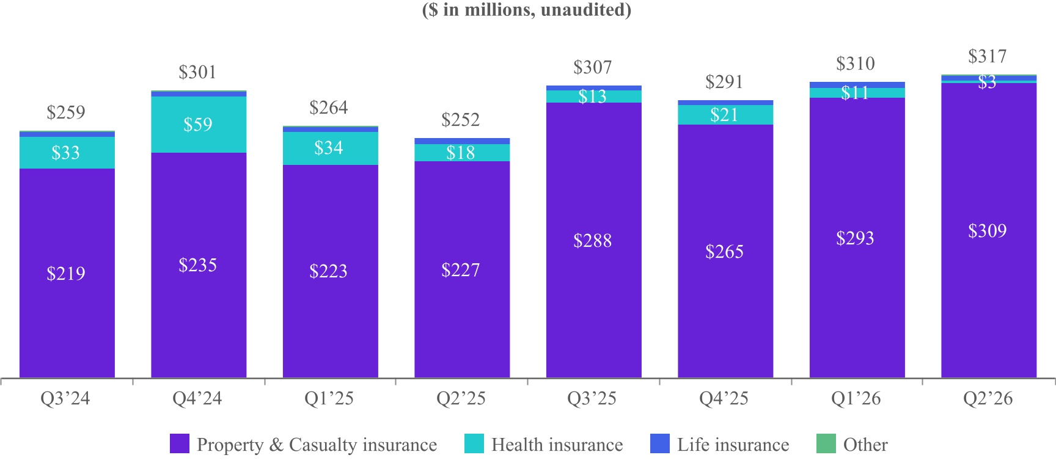
4
Revenue by Vertical and Platform Model

Revenue by Vertical |  |  | Three Months Ended June 30, |  |  |  |  |  |  |  |  |  |  |  | Six Months Ended June 30,
(in millions, except percentages, unaudited) |  |  | 2026 |  |  |  |  |  | 2025 |  |  |  |  |  | 2026 |  |  |  |  |  | 2025
Property & Casualty insurance |  |  | $ | 308.8 |  |  |  |  | $ | 227.2 |  |  |  |  | $ | 601.6 |  |  |  |  | $ | 450.4
Percentage of total Revenue |  |  | 97.4 |  | % |  |  |  | 90.3 |  | % |  |  |  | 96.0 |  | % |  |  |  | 87.3 |  | %
Health insurance |  |  | 2.7 |  |  |  |  |  | 18.1 |  |  |  |  |  | 13.9 |  |  |  |  |  | 52.0
Percentage of total Revenue |  |  | 0.9 |  | % |  |  |  | 7.2 |  | % |  |  |  | 2.2 |  | % |  |  |  | 10.1 |  | %
Life insurance |  |  | 5.1 |  |  |  |  |  | 5.2 |  |  |  |  |  | 11.0 |  |  |  |  |  | 10.8
Percentage of total Revenue |  |  | 1.6 |  | % |  |  |  | 2.1 |  | % |  |  |  | 1.7 |  | % |  |  |  | 2.1 |  | %
Other |  |  | 0.2 |  |  |  |  |  | 1.2 |  |  |  |  |  | 0.4 |  |  |  |  |  | 2.7
Percentage of total Revenue |  |  | 0.1 |  | % |  |  |  | 0.4 |  | % |  |  |  | 0.1 |  | % |  |  |  | 0.5 |  | %
Total Revenue |  |  | $ | 316.9 |  |  |  |  | $ | 251.6 |  |  |  |  | $ | 626.9 |  |  |  |  | $ | 515.9

Revenue by Platform Model |  |  | Three Months Ended June 30, |  |  |  |  |  |  |  |  |  |  |  | Six Months Ended June 30,
(in millions, except percentages, unaudited) |  |  | 2026 |  |  |  |  |  | 2025 |  |  |  |  |  | 2026 |  |  |  |  |  | 2025
Open Marketplace transactions |  |  | $ | 312.0 |  |  |  |  | $ | 245.3 |  |  |  |  | $ | 615.8 |  |  |  |  | $ | 503.7
Percentage of total Revenue |  |  | 98.5 |  | % |  |  |  | 97.5 |  | % |  |  |  | 98.2 |  | % |  |  |  | 97.6 |  | %
Private Marketplace transactions |  |  | 4.9 |  |  |  |  |  | 6.3 |  |  |  |  |  | 11.1 |  |  |  |  |  | 12.2
Percentage of total Revenue |  |  | 1.5 |  | % |  |  |  | 2.5 |  | % |  |  |  | 1.8 |  | % |  |  |  | 2.4 |  | %
Total Revenue |  |  | $ | 316.9 |  |  |  |  | $ | 251.6 |  |  |  |  | $ | 626.9 |  |  |  |  | $ | 515.9

5
Contribution1 & Contribution Margin
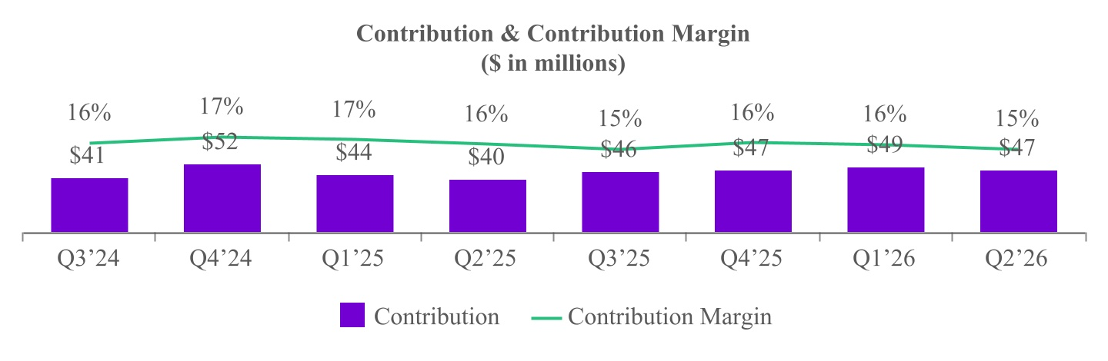

Adjusted EBITDA2
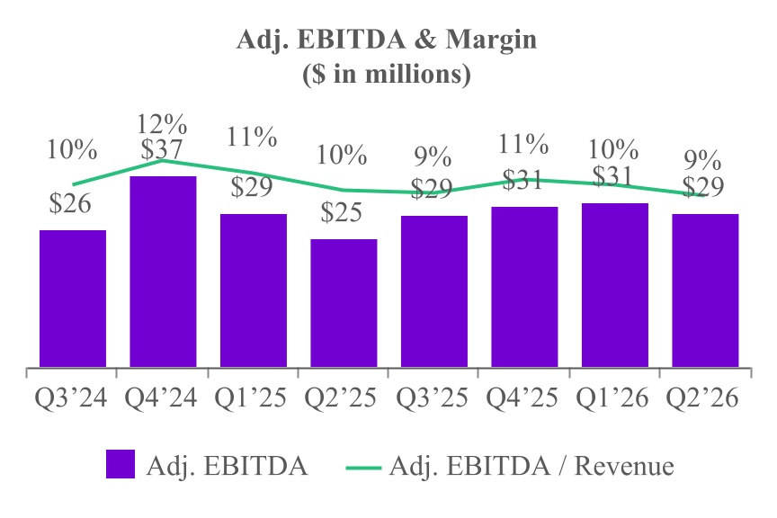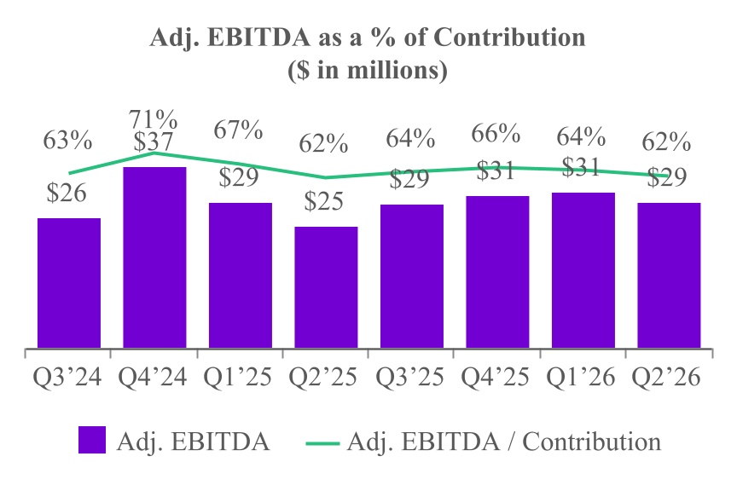
1 See page 11 of this supplement for additional information regarding Contribution, a non-GAAP financial measure.
2 See page 12 of this supplement for additional information regarding Adjusted EBITDA, a non-GAAP financial measure.

6
Share Repurchase Overview
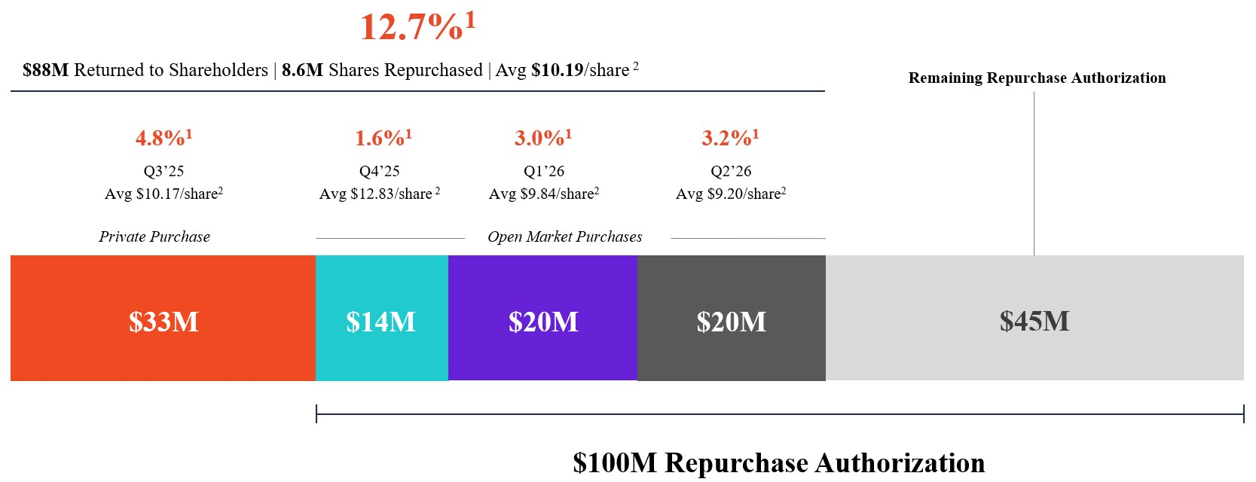

1 Represents shares repurchased as a percentage of the 67.9 million shares outstanding as of July 31, 2025.
2 Average price derived as consideration paid, excluding any commission, divided by the number of shares repurchased.
7
Repurchase of TRA Obligation from Insignia

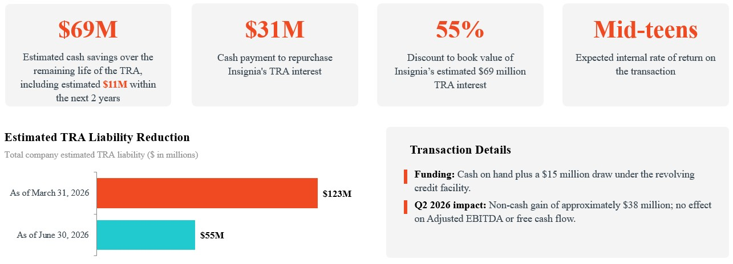

8
Q3 2026 Financial Outlook

 |  |  |  | Q3 2026 Guidance
($ in millions, % year-over-year growth) |  |  |  | Low |  |  | Mid |  |  | High
Revenue |  |  |  | $330.0 |  |  | $342.5 |  |  | $355.0
% growth |  |  |  | 8 |  | % | 12 |  | % | 16 |  | %
Contribution1 |  |  |  | $51.5 |  |  | $53.0 |  |  | $54.5
% growth |  |  |  | 13 |  | % | 16 |  | % | 19 |  | %
Adjusted EBITDA2 |  |  |  | $32.0 |  |  | $33.5 |  |  | $35.0
% growth |  |  |  | 10 |  | % | 15 |  | % | 20 |  | %
Under-65 Contribution |  |  |  | $0.3 |  |  | $0.3 |  |  | $0.3
Contribution excluding Under-65 Contribution |  |  |  | $51.3 |  |  | $52.8 |  |  | $54.3
% growth |  |  |  | 16 |  | % | 20 |  | % | 23 |  | %
Adjusted EBITDA excluding Under-65 Contribution |  |  |  | $31.8 |  |  | $33.3 |  |  | $34.8
% growth |  |  |  | 15 |  | % | 21 |  | % | 26 |  | %

1 See page 11 of this supplement for additional information regarding Contribution, a non-GAAP financial measure.
2 See page 12 of this supplement for additional information regarding Adjusted EBITDA, a non-GAAP financial measure.

9
Key Business Metrics
and Non-GAAP Financial Measures
In addition to traditional financial metrics, we rely upon certain business metrics that are not presented in accordance with GAAP to estimate the volume of spending on our platform, estimate and recognize revenue, evaluate our business performance and facilitate our operations. Such business metrics should not be considered in isolation from, or as an alternative to, measures presented in accordance with GAAP and should be considered together with other operating and financial performance measures presented in accordance with GAAP. Also, such business and operating metrics may not necessarily be comparable to similarly titled measures presented by other companies.
10
Contribution to Gross Profit
We define “Contribution” as revenue less revenue share payments and online advertising costs, or, as reported in our consolidated statements of operations, revenue less cost of revenue (i.e., gross profit), as adjusted to exclude the following items from cost of revenue: equity-based compensation; salaries, wages, and related costs; internet and hosting costs; amortization; depreciation; other services; and merchant-related fees. We define “Contribution Margin” as Contribution expressed as a percentage of revenue for the same period. Contribution and Contribution Margin are non-GAAP financial measures that we present to supplement the financial information we present on a GAAP basis. We use Contribution and Contribution Margin to measure the return on our relationships with our Supply Partners (excluding certain fixed costs), the financial return on and efficacy of our online advertising costs to drive consumers to our proprietary websites, and our operating leverage. We do not use Contribution and Contribution Margin as measures of overall profitability. We present Contribution and Contribution Margin because they are used by our management and board of directors to manage our operating performance, including evaluating our operational performance against budget and assessing our overall operating efficiency and operating leverage. For example, if Contribution increases and our headcount costs and other operating expenses remain steady, our Adjusted EBITDA and operating leverage increase. If Contribution Margin decreases, we may choose to re-evaluate and re-negotiate our revenue share agreements with our Supply Partners, to make optimization and pricing changes with respect to our bids for keywords from primary traffic acquisition sources, or to change our overall cost structure with respect to headcount, fixed costs and other costs. Other companies may calculate Contribution and Contribution Margin differently than we do. Contribution and Contribution Margin have their limitations as analytical tools, and you should not consider them in isolation or as substitutes for analysis of our results presented in accordance with GAAP.
The following table reconciles Contribution with gross profit, the most directly comparable financial measure calculated and presented in accordance with GAAP, for the three and six months ended June 30, 2026 and 2025:
 |  |  | Three Months Ended June 30, |  |  |  |  |  |  |  |  |  |  |  | Six Months Ended June 30,
(in thousands) |  |  | 2026 |  |  |  |  |  | 2025 |  |  |  |  |  | 2026 |  |  |  |  |  | 2025
Revenue |  |  | $ | 316,875 |  |  |  |  | $ | 251,622 |  |  |  |  | $ | 626,879 |  |  |  |  | $ | 515,931
Less cost of revenue |  |  | (271,701) |  |  |  |  |  | (213,935) |  |  |  |  |  | (535,006) |  |  |  |  |  | (436,605)
Gross profit |  |  | $ | 45,174 |  |  |  |  | $ | 37,687 |  |  |  |  | $ | 91,873 |  |  |  |  | $ | 79,326
Adjusted to exclude the following (as related to cost of revenue):
Equity-based compensation |  |  | 106 |  |  |  |  |  | 277 |  |  |  |  |  | 249 |  |  |  |  |  | 571
Salaries, wages, and related |  |  | 381 |  |  |  |  |  | 785 |  |  |  |  |  | 726 |  |  |  |  |  | 1,601
Internet and hosting |  |  | 343 |  |  |  |  |  | 200 |  |  |  |  |  | 598 |  |  |  |  |  | 371
Other expenses |  |  | 130 |  |  |  |  |  | 165 |  |  |  |  |  | 277 |  |  |  |  |  | 367
Depreciation |  |  | 2 |  |  |  |  |  | 6 |  |  |  |  |  | 5 |  |  |  |  |  | 12
Other services |  |  | 737 |  |  |  |  |  | 528 |  |  |  |  |  | 1,569 |  |  |  |  |  | 1,240
Merchant-related fees |  |  | 285 |  |  |  |  |  | 188 |  |  |  |  |  | 525 |  |  |  |  |  | 330
Contribution |  |  | $ | 47,158 |  |  |  |  | $ | 39,836 |  |  |  |  | $ | 95,822 |  |  |  |  | $ | 83,818
Gross margin |  |  | 14.3 |  | % |  |  |  | 15.0 |  | % |  |  |  | 14.7 |  | % |  |  |  | 15.4 |  | %
Contribution Margin |  |  | 14.9 |  | % |  |  |  | 15.8 |  | % |  |  |  | 15.3 |  | % |  |  |  | 16.2 |  | %
11
Adjusted EBITDA to Net Income (Loss)
We define “Adjusted EBITDA” as net income (loss) excluding interest expense, income tax expense (benefit), depreciation expense on property and equipment, amortization of intangible assets, as well as equity-based compensation expense and certain other adjustments as listed in the table below. We define “Adjusted EBITDA Margin” as Adjusted EBITDA as a percentage of revenue. Adjusted EBITDA is a non-GAAP financial measure that we present to supplement the financial information we present on a GAAP basis. We monitor and present Adjusted EBITDA because it is a key measure used by our management to understand and evaluate our operating performance, to establish budgets and to develop operational goals for managing our business. We believe that Adjusted EBITDA helps identify underlying trends in our business that could otherwise be masked by the effect of the expenses that we exclude in the calculations of Adjusted EBITDA. Accordingly, we believe that Adjusted EBITDA provides useful information to investors and others in understanding and evaluating our operating results, enhancing the overall understanding of our past performance and future prospects. In addition, presenting Adjusted EBITDA provides investors with a metric to evaluate the capital efficiency of our business. Adjusted EBITDA is not presented in accordance with GAAP and should not be considered in isolation of, or as an alternative to, measures presented in accordance with GAAP. There are a number of limitations related to the use of Adjusted EBITDA rather than net income, which is the most directly comparable financial measure calculated and presented in accordance with GAAP. These limitations include the fact that Adjusted EBITDA excludes interest expense on debt, income tax expense (benefit), equity-based compensation expense, depreciation and amortization, and certain other adjustments that we consider to be useful to investors and others in understanding and evaluating our operating results. In addition, other companies may use other measures to evaluate their performance, including different definitions of “Adjusted EBITDA,” which could reduce the usefulness of our Adjusted EBITDA as a tool for comparison.
The following table reconciles Adjusted EBITDA with net income (loss), the most directly comparable financial measure calculated and presented in accordance with GAAP, for the three and six months ended June 30, 2026 and 2025:
 |  |  | Three Months Ended June 30, |  |  |  |  |  |  |  |  |  |  |  | Six Months Ended June 30,
(in thousands) |  |  | 2026 |  |  |  |  |  | 2025 |  |  |  |  |  | 2026 |  |  |  |  |  | 2025
Net income (loss) |  |  | $ | 41,783 |  |  |  |  | $ | (22,533) |  |  |  |  | $ | 55,829 |  |  |  |  | $ | (24,867)
Equity-based compensation expense |  |  | 8,472 |  |  |  |  |  | 8,112 |  |  |  |  |  | 15,731 |  |  |  |  |  | 15,136
Interest expense |  |  | 2,774 |  |  |  |  |  | 2,870 |  |  |  |  |  | 5,215 |  |  |  |  |  | 5,825
Income tax expense |  |  | 13,308 |  |  |  |  |  | 316 |  |  |  |  |  | 19,810 |  |  |  |  |  | 267
Depreciation expense on property and equipment |  |  | 76 |  |  |  |  |  | 68 |  |  |  |  |  | 150 |  |  |  |  |  | 130
Amortization of intangible assets |  |  | 478 |  |  |  |  |  | 512 |  |  |  |  |  | 955 |  |  |  |  |  | 1,956
Transaction expenses(1) |  |  | — |  |  |  |  |  | — |  |  |  |  |  | 1,298 |  |  |  |  |  | —
Write-off of intangible assets(2) |  |  | — |  |  |  |  |  | — |  |  |  |  |  | — |  |  |  |  |  | 13,416
Gain on repurchase of interests in tax receivables agreement |  |  | (37,651) |  |  |  |  |  | — |  |  |  |  |  | (37,651) |  |  |  |  |  | —
Changes in TRA related liability(3) |  |  | (52) |  |  |  |  |  | 79 |  |  |  |  |  | (855) |  |  |  |  |  | 79
Changes in Tax Indemnification Receivable |  |  | (86) |  |  |  |  |  | (185) |  |  |  |  |  | (69) |  |  |  |  |  | (206)
Legal expenses(4) |  |  | 167 |  |  |  |  |  | 35,263 |  |  |  |  |  | 216 |  |  |  |  |  | 42,142
Adjusted EBITDA |  |  | $ | 29,269 |  |  |  |  | $ | 24,502 |  |  |  |  | $ | 60,629 |  |  |  |  | $ | 53,878
(1)Transaction expenses for the six months ended June 30, 2026 consist of legal and other fees of $1.1 million and a loss on extinguishment of debt of $0.2 million incurred by us in connection with the 2026 Credit Facilities.
(2)Write-off of intangible assets for the six months ended June 30, 2025 consists of a charge related to the write-off of customer relationships and trademarks, trade names, and domain names intangible assets acquired as part of the acquisition of Customer Helper Team, LLC.
(3)Changes in TRA related liability consist of adjustments to the TRA liability to reflect probable future payments under the agreement.
(4)Legal expenses for the three and six months ended June 30, 2026 were immaterial. Legal expenses for the three and six months ended June 30, 2025, consist of increases of $33.0 million and $38.0 million, respectively, to the loss reserve established in connection with the FTC Matter and legal fees and costs incurred in connection with such matter.
12

